**Alekhya Krishna Balivada Azure Databricks Assessment -1 (28-12-2023)**

**Azure Account Creation**

**Step-1:** Login to the make my labs workspace with the given login credentials

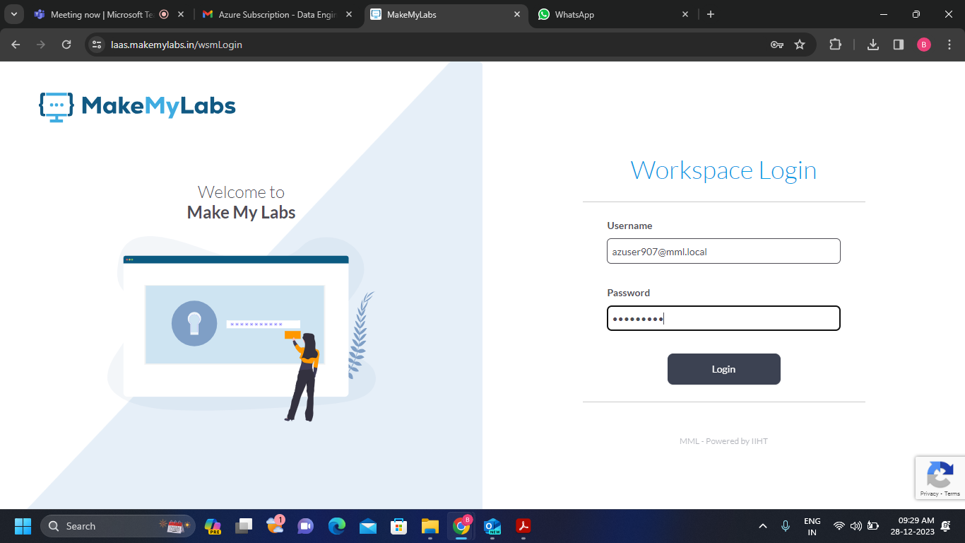

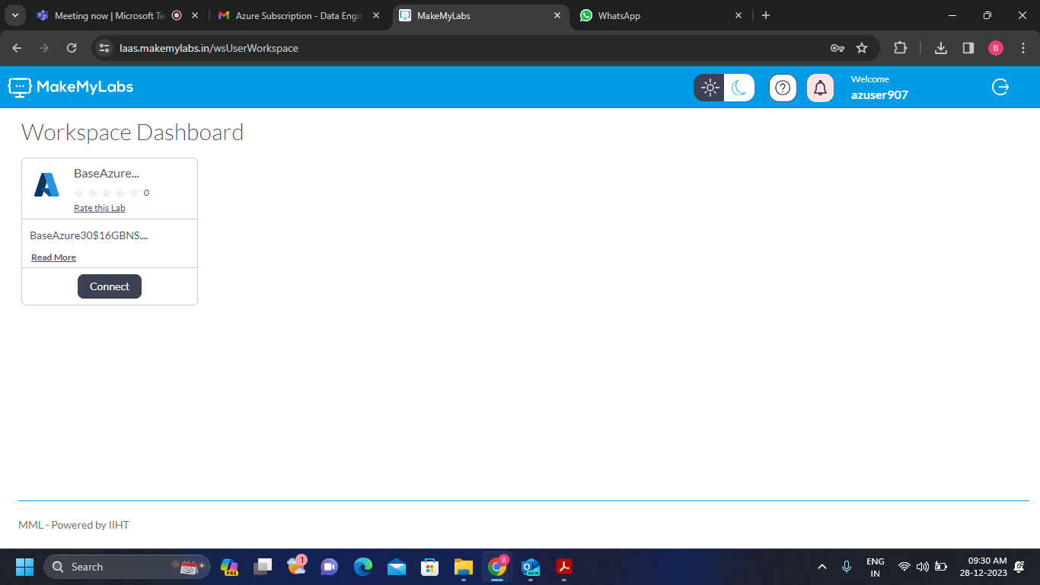**Step-2:** We get the following dashboard and click on connect.

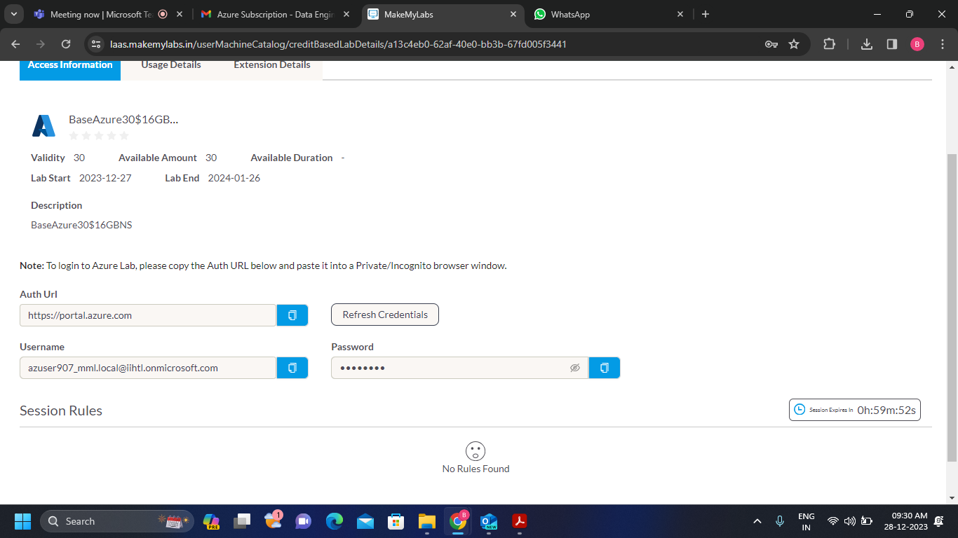**Step – 3:** Click on generate link the we get the Auth Url credentials with user name and password.

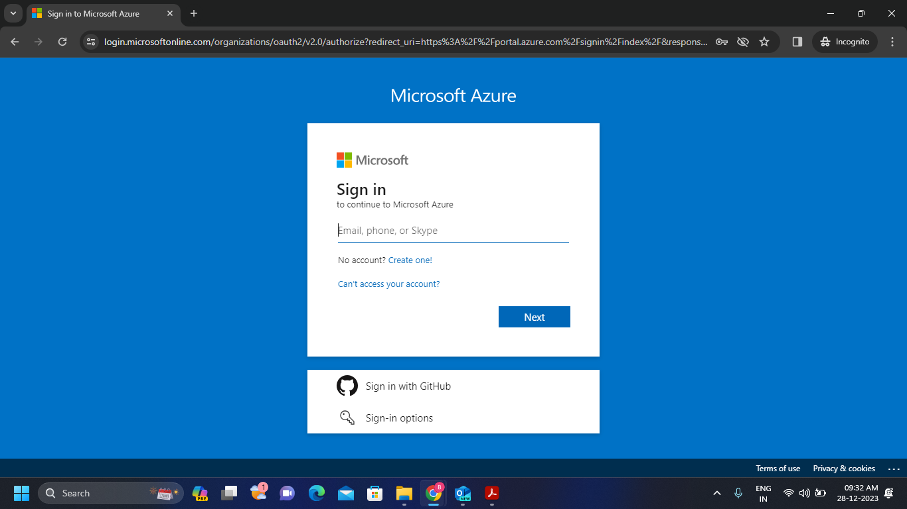**Step-4:** Copy the above generated url and paste that url in new tab with incognito mode

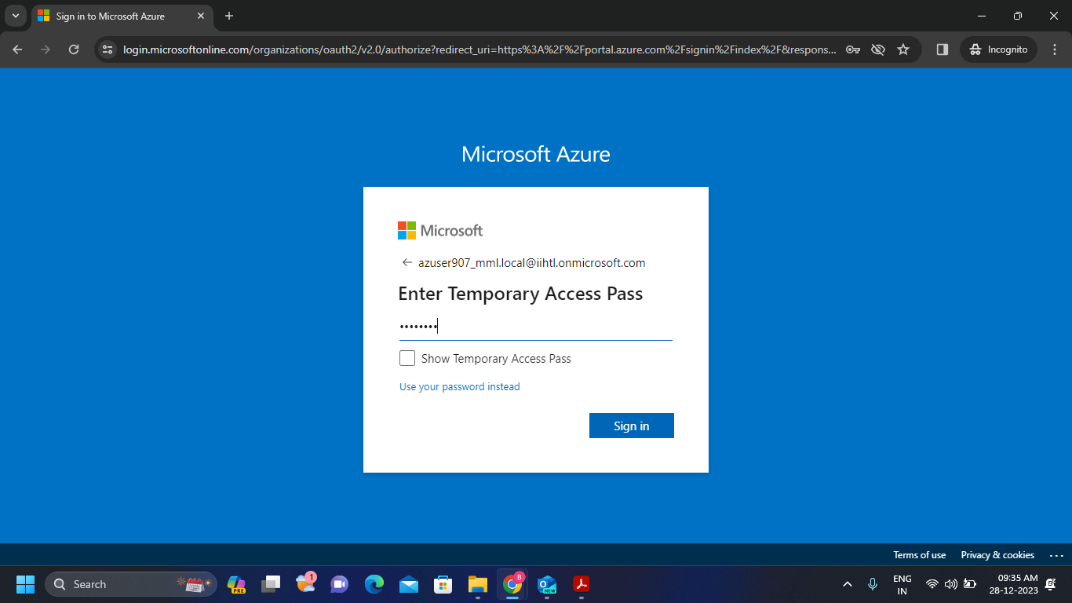**Step – 5:** After that give the used-id and password which is given as above.

**Step – 6:** We get the following window. We successfully logged into our Azure account.

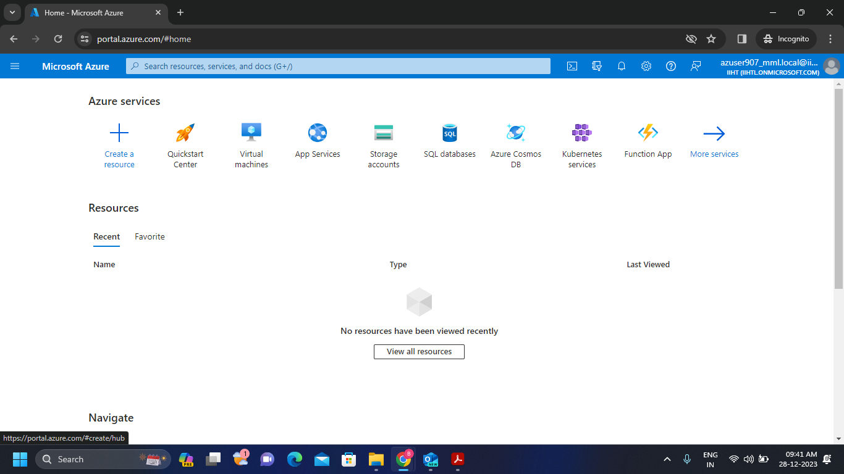

**Azure Databricks**: Azure Databricks is a unified, open analytics platform for building, deploying, sharing, and maintaining enterprise-grade data, analytics, and AI solutions at scale.

* Azure Databricks is like a cloud platform where we can access the databricks and Apache Spark.
* Databricks is like a collection of different services of Apache Spark.

